[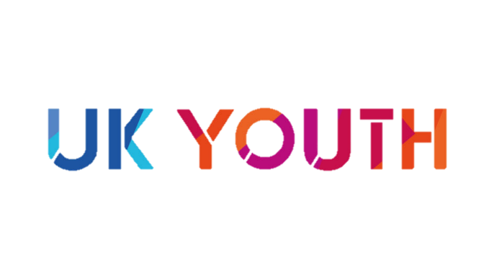](https://www.ukyouth.org/)

© UK Youth 2021 | Charity No: 1110590

**I have made a donation of £** [amount] **to UK Youth in your name.**

This donation has been **doubled** as part of UK Youth’s Big Give campaign, and will support young people taking on social action as part of [#iwill.](https://www.iwill.org.uk/)

Have a wonderful festive season!

Love, [name]

Dear [name]