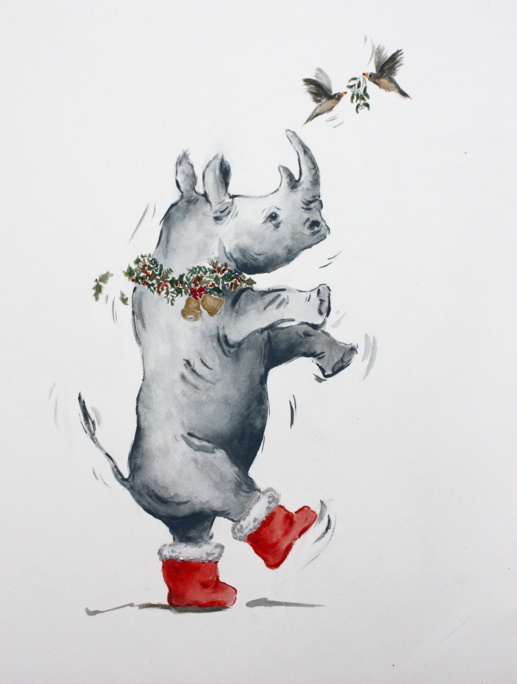

Dear [insert name]

**I have made a donation of £ [insert amount] to UK Youth in your name.**

This donation has been **doubled** as part of UK Youth’s Big Give campaign, and will support young people in the UK taking on social actions projects as part of #iwill.

Have a wonderful festive season!

Love,

[insert name]

© UK Youth 2021 | Charity No: 1110590 | 8th Floor, Kings Buildings, 16 Smith Square, SW1P 3HQ

**© Annabel Pope, Christmas Boots**

[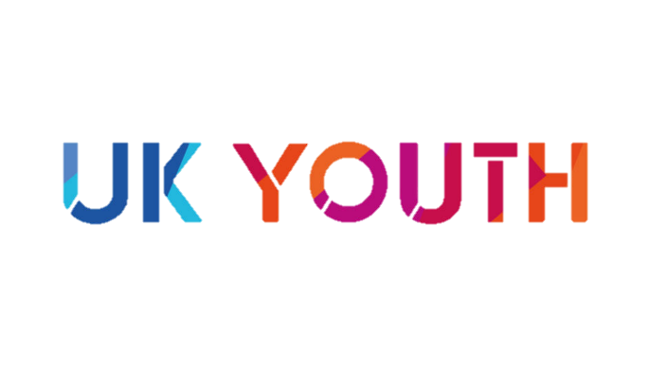](https://www.ukyouth.org/)

UK Youth | Charity No: 1110590

Christmas boots - original pen and wash by Annabel Pope. © Copyright the artist.   
[www.annabelpope.com](http://www.annabelpope.com)