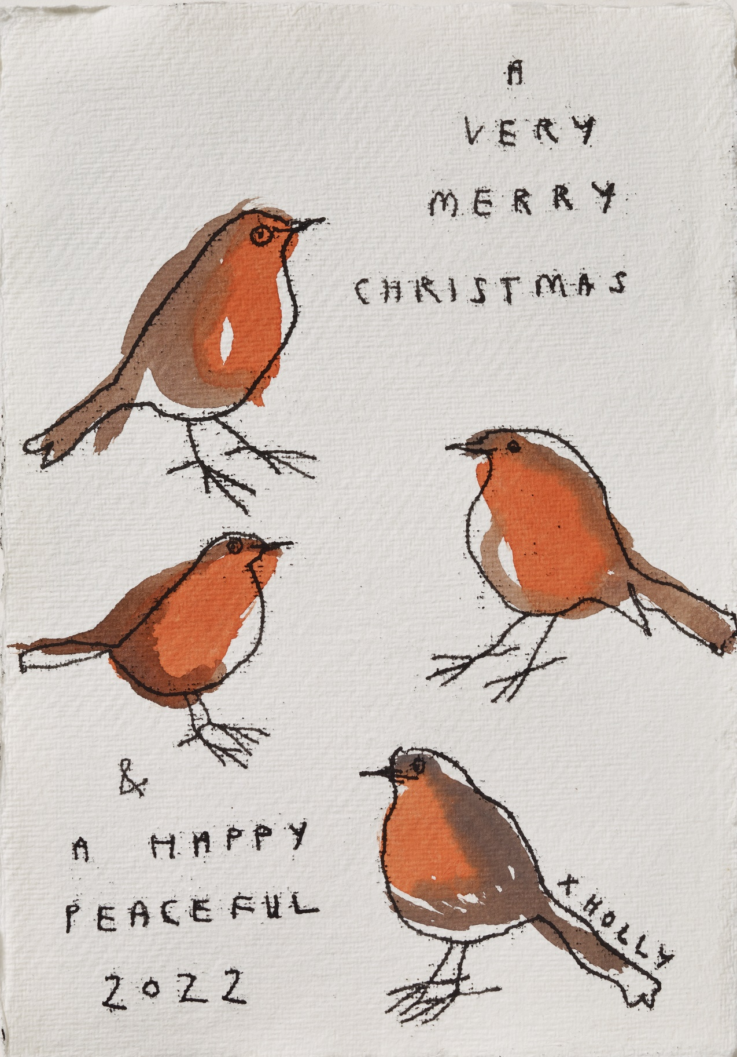

© Holly Frean, Four Robins, <https://www.instagram.com/hollyfrean/?hl=en>

Dear [insert name]

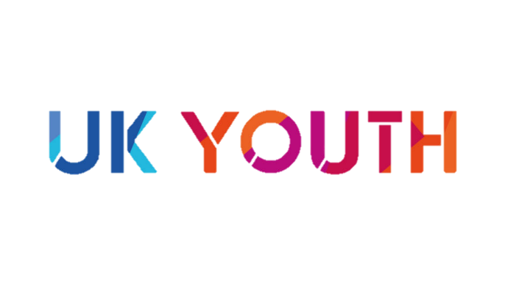

**I have made a donation of £** [insert amount] **to UK Youth in your name.**

This donation has been **doubled** as part of UK Youth’s Big Give campaign, and will support young people in the UK taking on social actions projects as part of #iwill.

Have a wonderful festive season!

Love,

[insert name]

© UK Youth 2021 | Charity No: 1110590 | 8th Floor, Kings Buildings, 16 Smith Square, SW1P 3HQ

**© Annabel Pope, Christmas Boots**

UK Youth | Charity No: 1110590